**Quick Demo**

Anton Kovalyov

axk176431

This a quick demo of the supported functionalities. Please note that all queries include adequate error handling, which will not be covered here since there are many different types of errors that can occur...

All the following queries are executed while reading/writing from/to files. Thus, the states are saved to disk.

**VDL:**

1. EXIT;
2. SELECT * FROM <table_name> [WHERE condition];

Condition includes the column name followed by an operator and the value. The operators =, <, <=, >, >=, !=, IS NULL, IS NOT NULL are included.

Example:

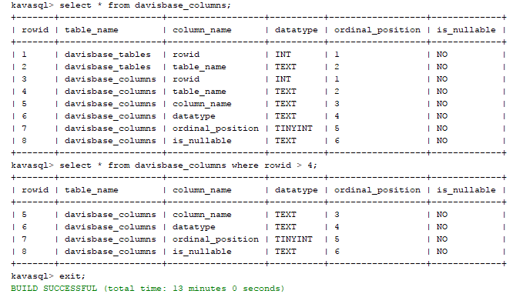

**DDL:**

1. CREATE TABLE table_name(

column_name int primary key,

column_name2 datatype [NOT NULL],

…);

1. SHOW TABLES;
2. DROP TABLE table_name;

Example:

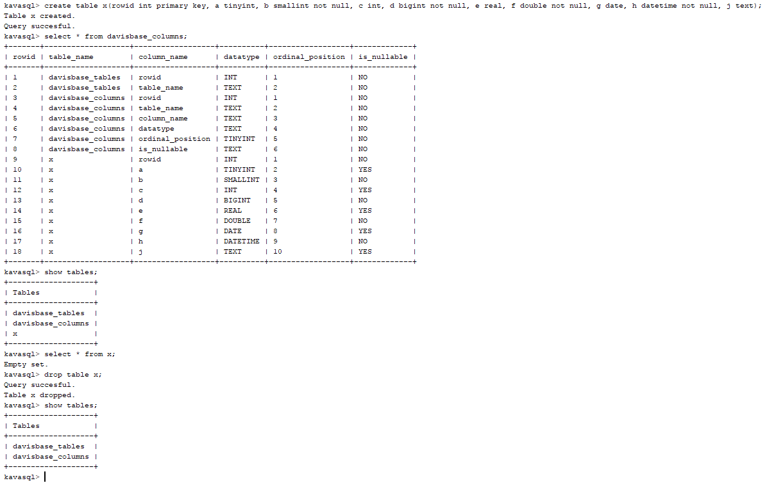

**DML:**

1. INSERT INTO table_name [column_list] VALUES (value1, value2, …);
2. DELETE FROM table_name where rowid = value;
3. UPDATE table_name SET column_name = value [WHERE condition];

Example: